# Design of “A Very Random Quiz” Website

## Introduction

“The Very Random Quiz” website is a trivia quiz. It consists of five questions varying in topic and level of difficulty. If the user answers at least four questions correctly, they are rewarded with a dad joke. If the user answers at least two incorrectly, they are punished with an inspirational quote.

## Goals

* Simple layout that is thematically consistent
* Load a random question every time a button is pressed
* Display a random inspirational quote if at least two answers are incorrect
* Display a random dad joke if at least four answers are correct
* Responsive on various devices

## Choice of APIs

The website uses three APIs: a trivia API (Open Trivia Database), a dad joke API (Icanhazdadjoke) and an inspirational quote API (Forismatic). The purpose of the website is to function as a quiz game. The trivia API provides random questions and multiple answers. Implementing this API creates a varied quiz with different questions every time. The dad joke API and inspirational quote API are utilised at the end of the quiz. If the user passes, the website displays a joke generated by the dad joke API. If the user fails, the website displays a quote generated by the inspirational quote API.

## Design Theme

This website was designed with the concept of a modern web page in mind—maintaining a minimalist design and a simple code (Takada). A minimalist design was achieved by maintaining a consistent colour palette: a cream background, grey fonts and orange accents. The orange colour was chosen specifically because it is psychologically proven to stimulate creativity and fun (Create a Website). The background and font are subdued colours to make the orange accent pop more. To further maintain a minimalist design, all of the text is in the same sans-serif font and only appears in two different sizes.

The title of page “A Very Random Quiz” is in a bigger size than other text. There is no space between the word Quiz and the rest of the title. It is also orange and slightly bigger. This was chosen specifically for the aesthetic of making the word Quiz the focal point. It is also a hyperlink that leads back to the ‘home display’ and reloads the quiz.

The original design consisted of three HTML pages, but in order to maintain simple code, the design was restructured to just one HTML page. Doing so also eliminated the issue of losing changing data (i.e. the score) through the process of retrieving a new HTML page. The website has four displays: ‘Home Display’, ‘Quiz Display’, and ‘Results Display’. The basic structure consists of one flexbox with four divs: the ‘title div’, the ‘question div’, the ‘answer div’ and the ‘button div’. The ‘title div’ is the only div with consistent content throughout all of the displays, so it is the only text written into the HTML. The rest of the divs are empty as their content changes with each display and was implemented with JavaScript rather than with HTML.

### Home Display

This is the first display the user sees. When this page loads, all the APIs are called and loaded, but hidden. The instructions appear in the ‘question div’. There is no content in the answer div so it is emptied and hidden to avoid a scroll bar. The instructions are followed by a button that says, “Let’s Play”. As all of this content only appears on the ‘home display’, it was written into the JavaScript file. When the button is clicked, the page will switch to the ‘quiz display’.

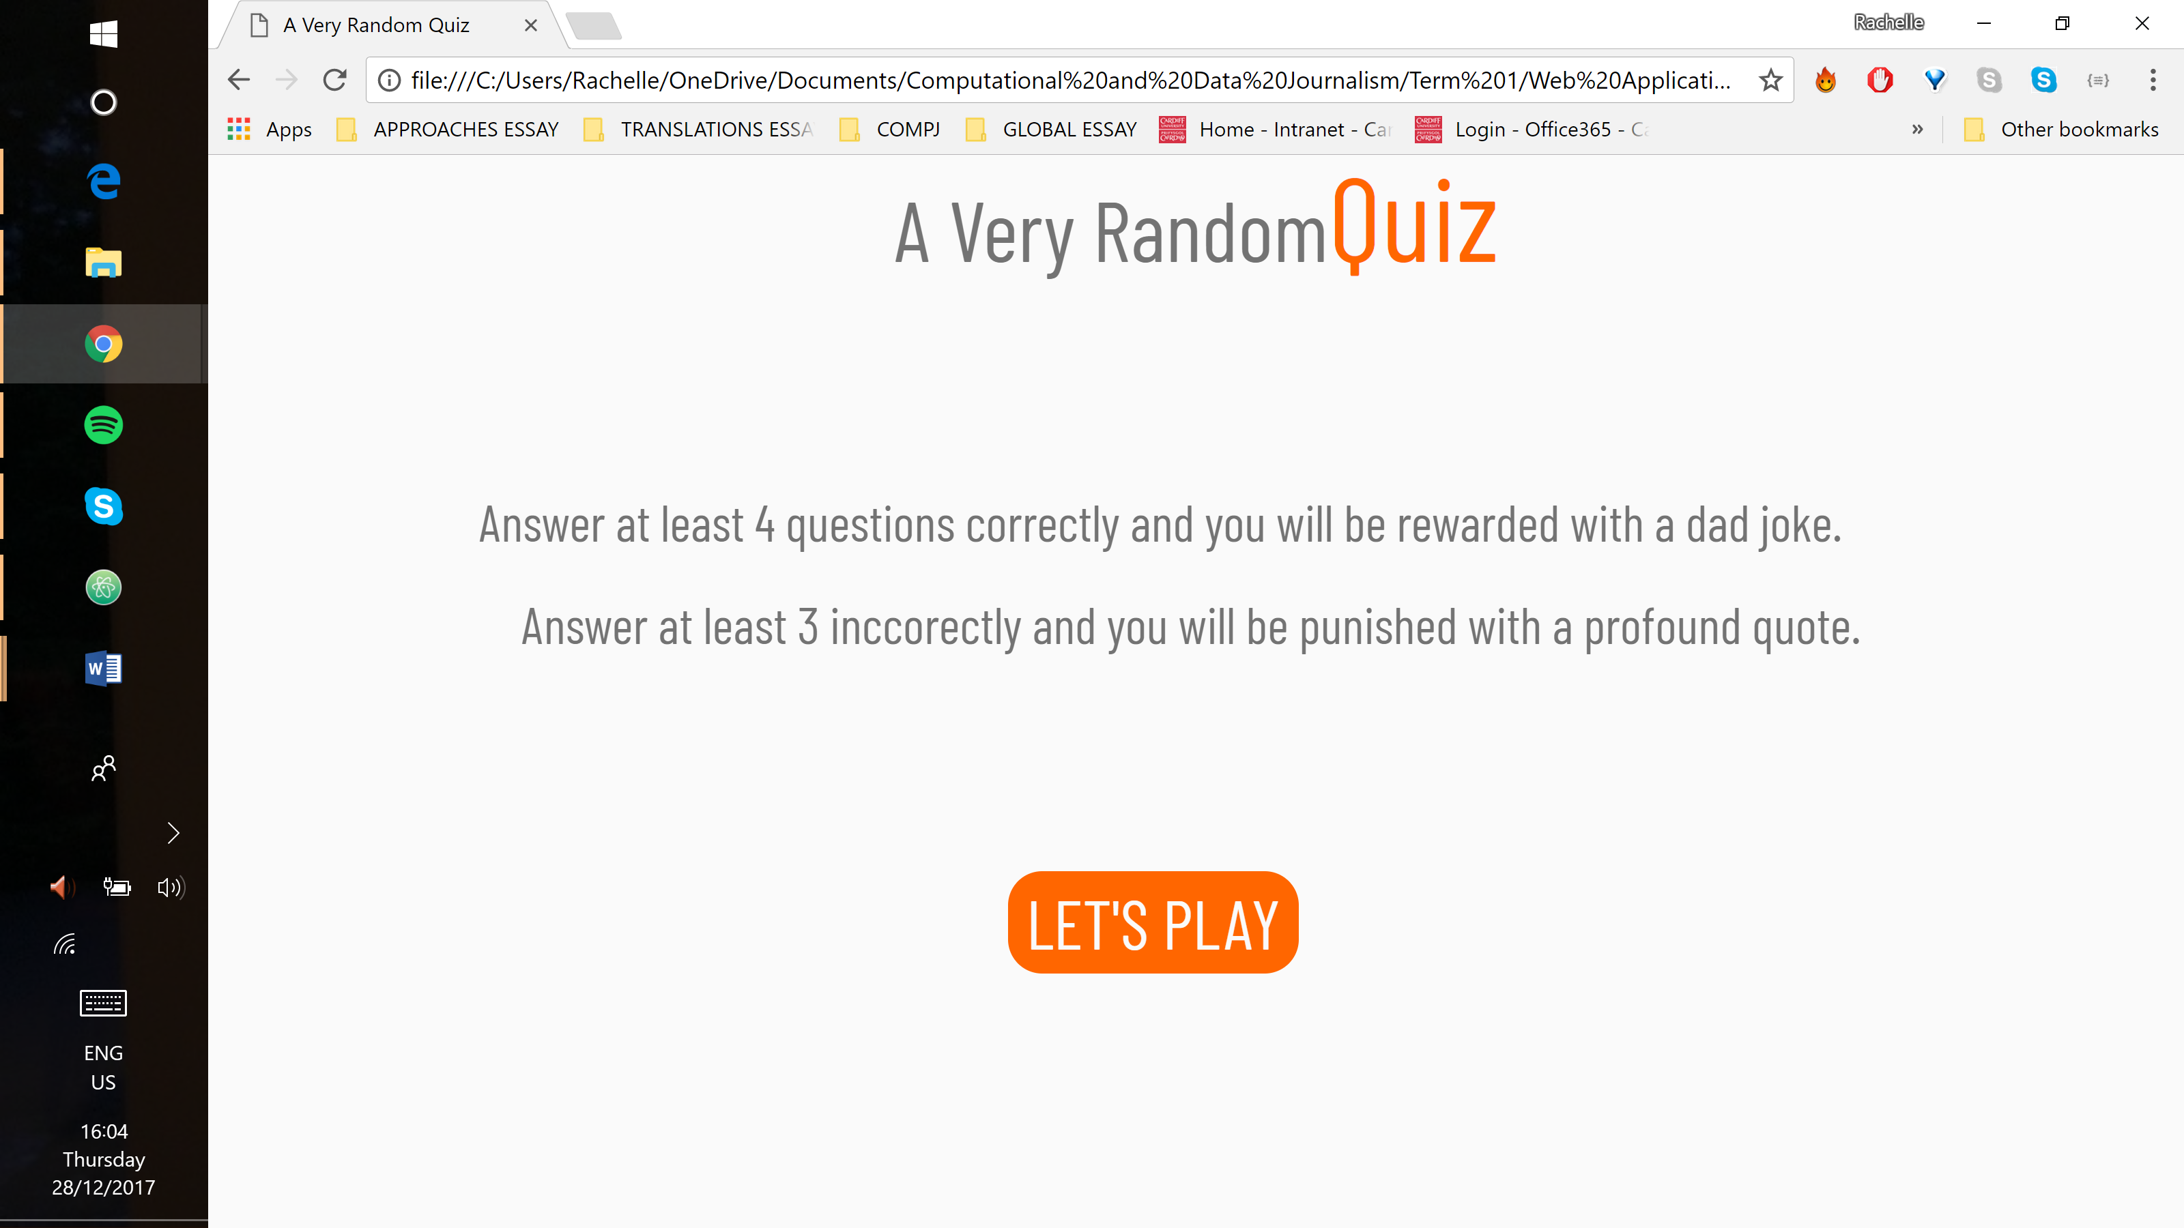

### Quiz Display

The title remains at the top of the page as in the ‘home display’. The instructions in the ‘question div’ are replaced with the question loaded from the trivia API. The API also supplied the possible answers which fill the ‘answer div’. They are structured with radio buttons and the selected answer turns orange. At the bottom, the button now says ‘NEXT’. This display remains for four of the five questions.

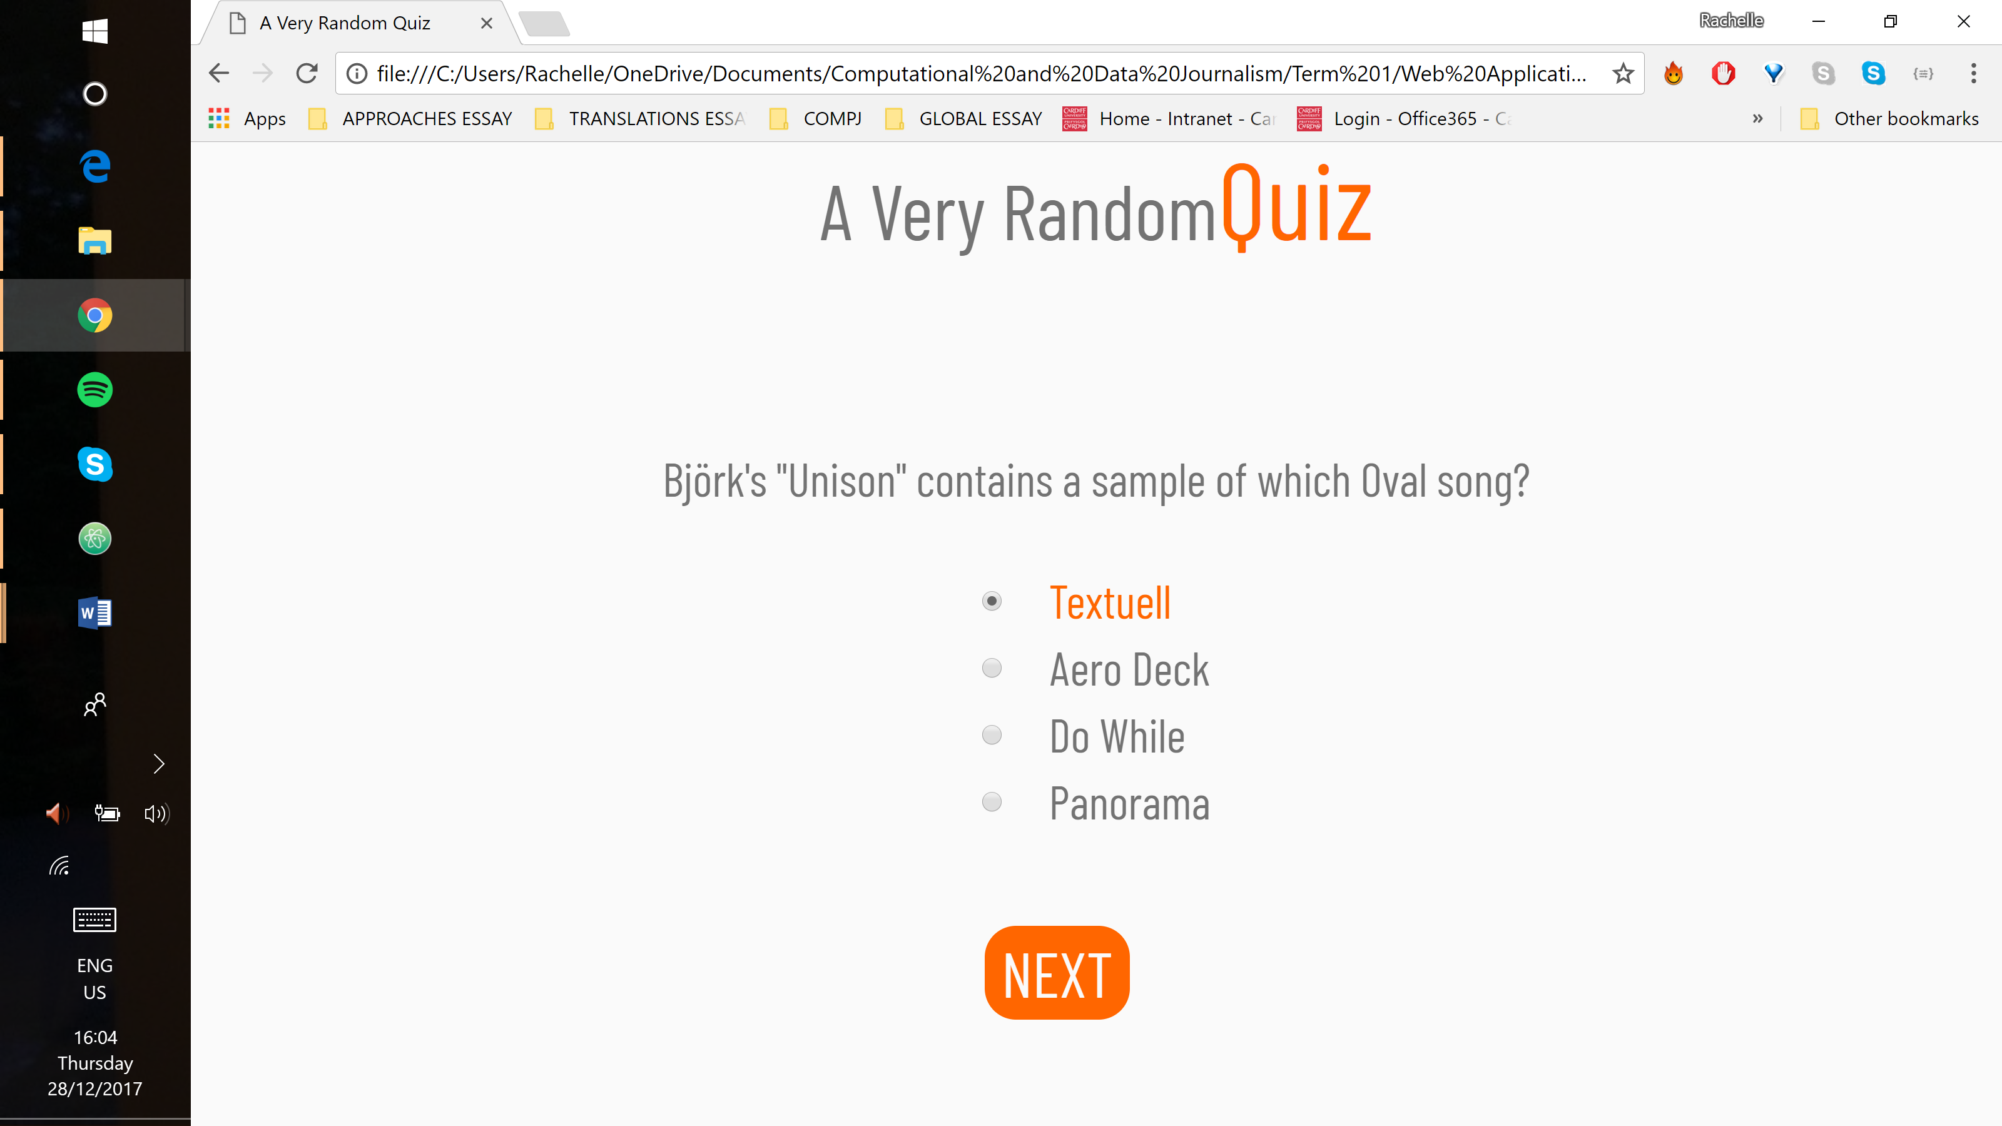

On the last question, the button changes to ‘SUBMIT’. Depending on the user’s score, clicking the button will load either a joke or a quote and the page will switch to the ‘results display’.

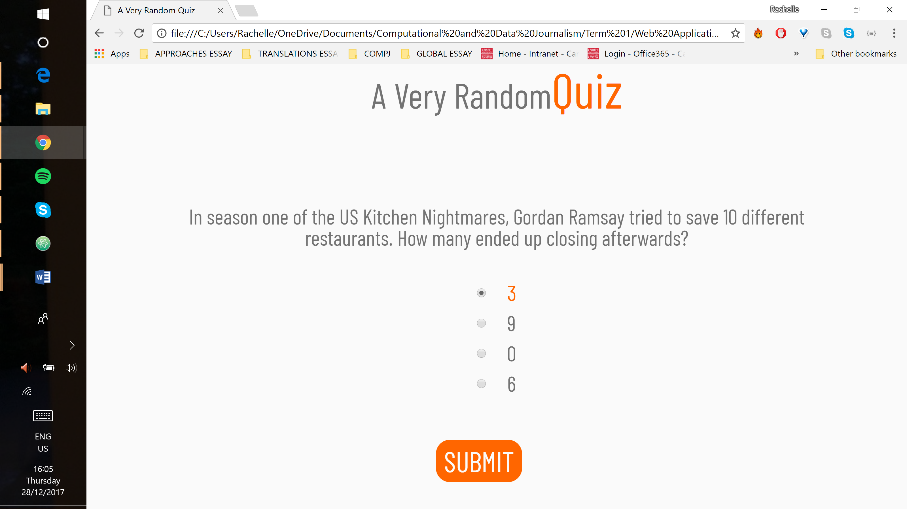

### Results Display

If the user passed, the question is replaced with a dad joke and the button reads “Good Job! Play Again?” If the user failed, the question is replaced with an inspirational quote and the button reads “You Suck! Play Again?” The ‘answers div’ is empty so, just like in the home display, it is emptied and hidden, moving the button further up the page. When the results are shown, each API loads new content. Clicking the button redirects the user to the quiz display rather than the home display and automatically displays the already loaded questions.

## Validation

### HTML Validation

There are no mistakes in the HTML code.

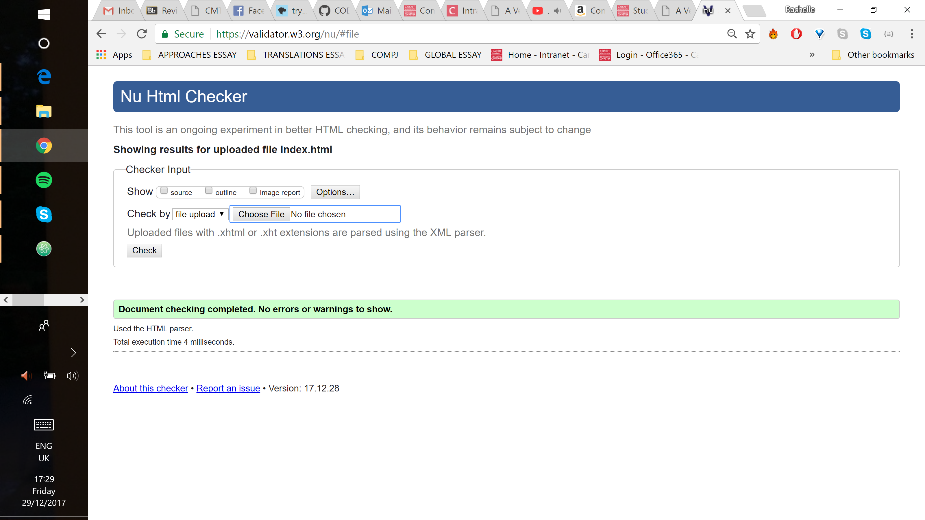

### CSS Validation

There are no mistakes in the CSS code.

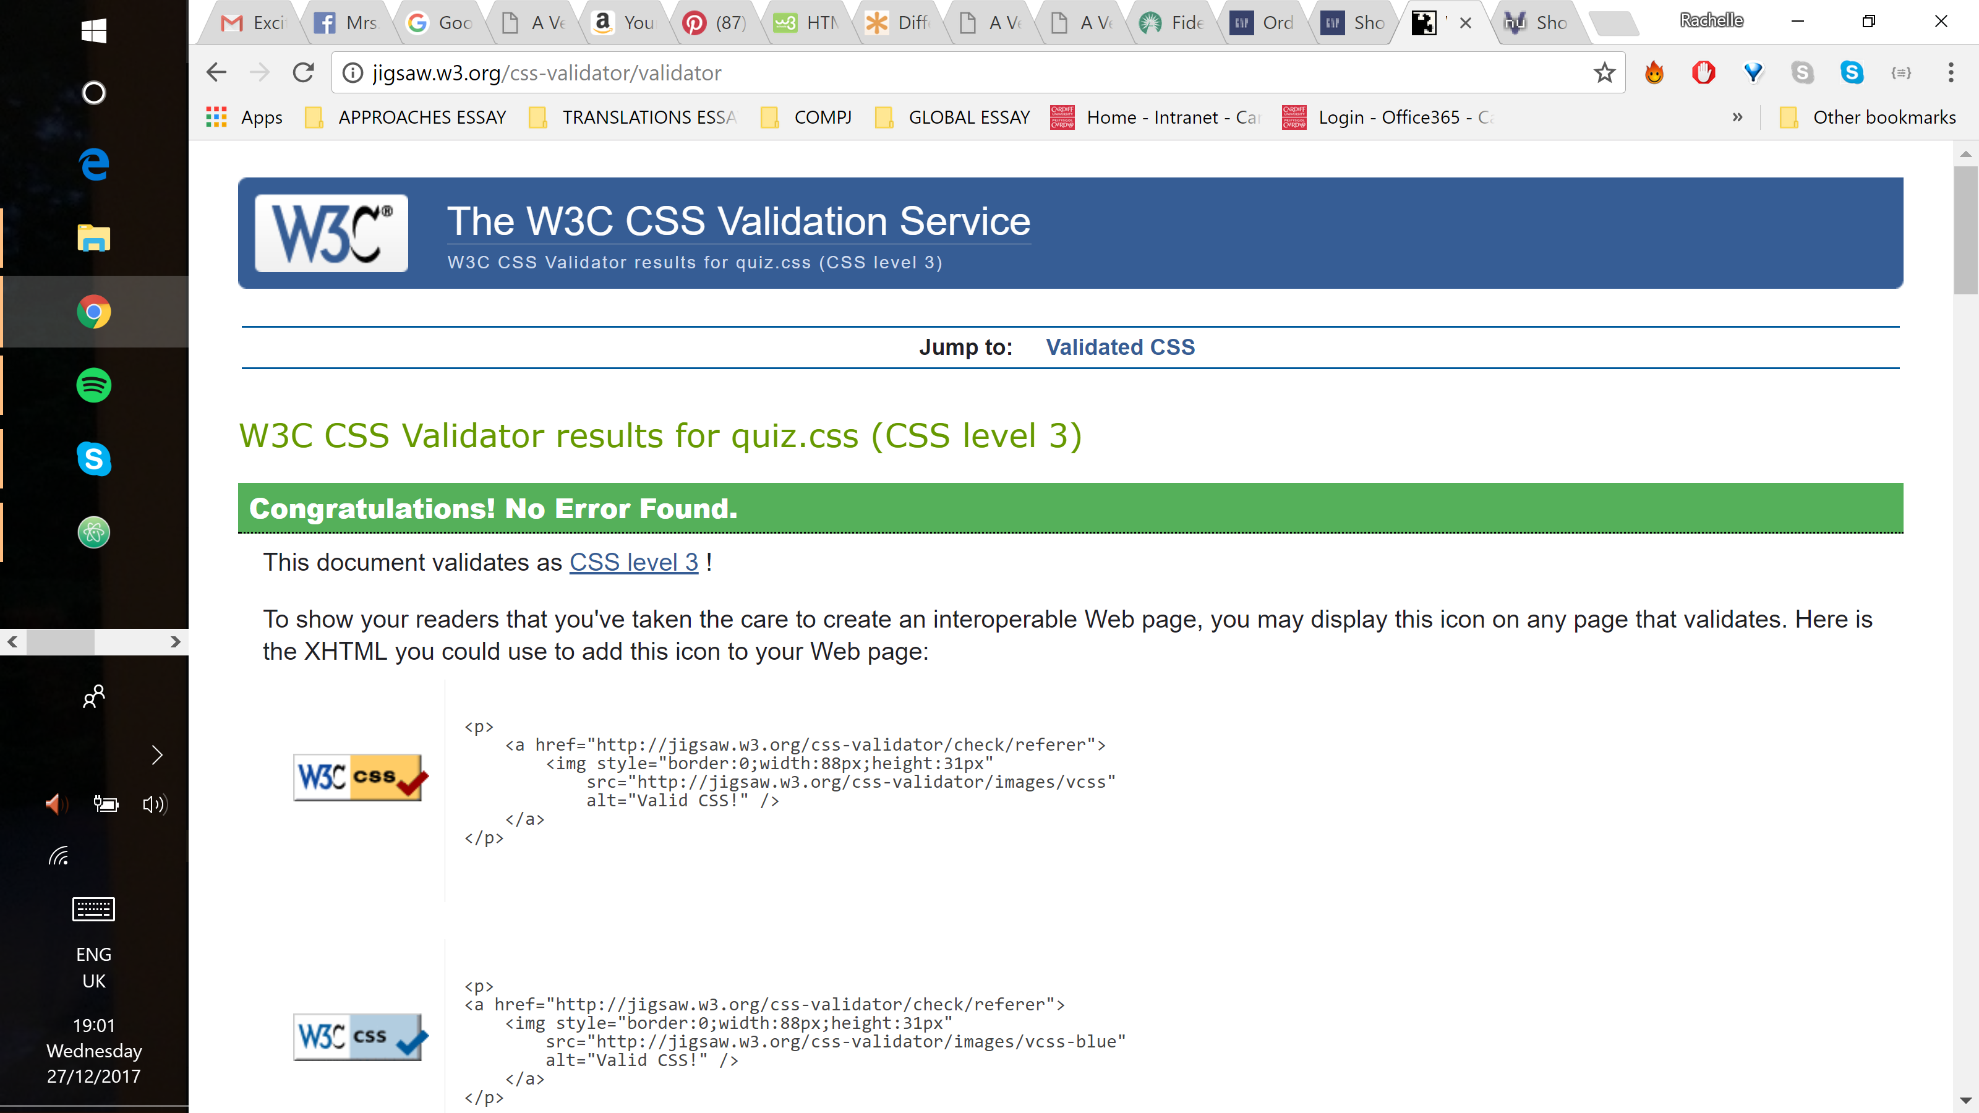

## Evaluation

The website consists of one HTML page styled and positioned with CSS elements. JavaScript was used to call the APIs and to add interactivity to the website. The website demonstrates the ability to access web APIs and to retrieve, manipulate and display data. Browser debugger tools were used to better understand the performance and the execution of code in the browser. The website also demonstrates the ability to assess the role of web frameworks in web application development.

The site displays and operates exactly as intended both on desktop and on mobile devices. Media queries were not used since the design is vertical and relatively simple. Any necessary alterations for mobile devices could be made in the main css without impacting the desktop display.

### Issues

Testing mobile devices in the Chrome browser proved difficult as developer tools display blocked out half of the phone screen. Since only half of the screen was displayed, a scroll bar appeared. It is assumed that this is a browser issue and that on an actual mobile device, the full height will be visible. This issue is demonstrated in the images below.

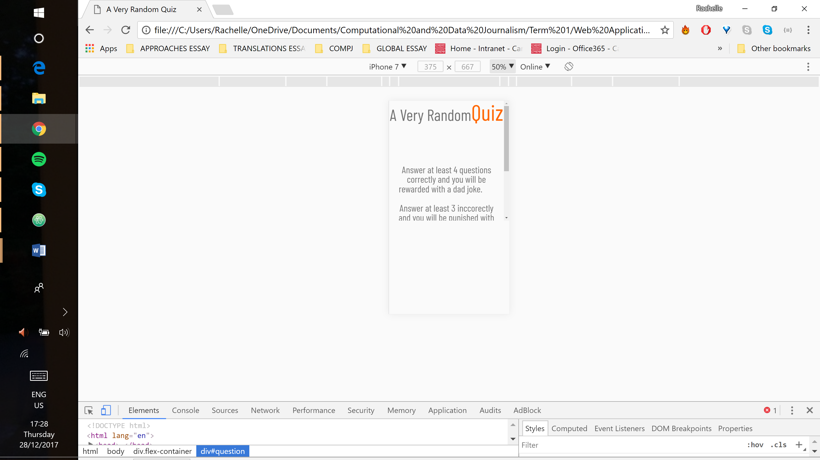 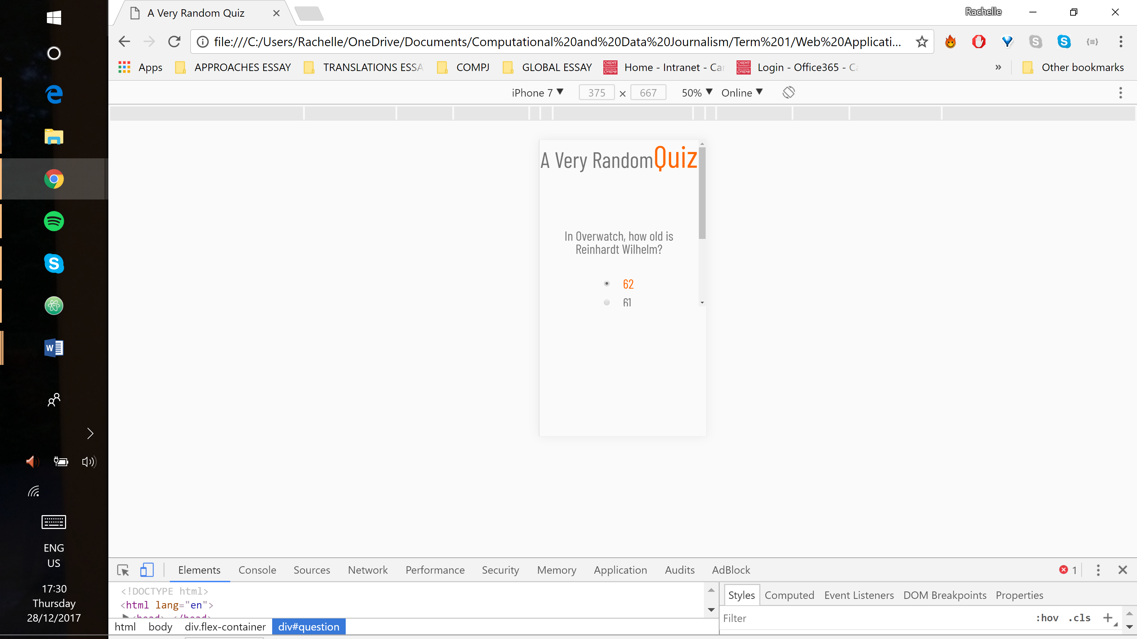

The home display button loads slowly. It is programmed to be hidden until all of the API data is loaded which may be the cause of the delay. Below is a screenshot before the button had appeared.

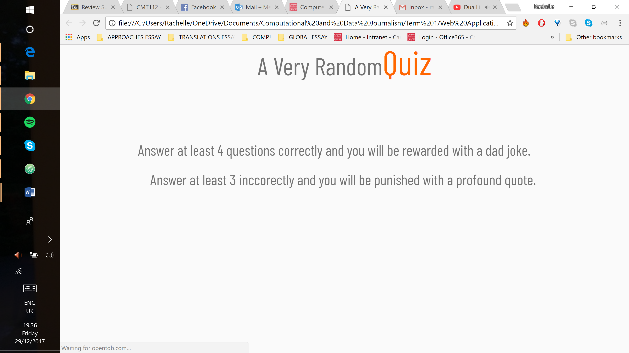

Some of the APIs require loading resources across domains. While in some situations this may be a security concern, it is not for a quiz app. Unfortunately, full resolution may require manipulation of a number of headers in the API request. Full information on the exact set and values of the headers was not found on the Internet and required experimentation to figure out.

Since a number of people had identical problems which helped to determine a workaround. It involved requesting a response in the JSONP format instead of JSON. This format returns JavaScript code that calls a function with the requested object. One of the parameters to the API call supplied the name of the function to call. The trick involved creating a script object in the document and setting its source to the API call URL. This loads the response from the supplied URL, which is the above-mentioned JavaScript that makes a call to a previously defined function. This method was used to obtain a quote from inspirational quote API.

## Conclusion

This website demonstrates an improved knowledge in HTML and CSS and a growing knowledge of JavaScript. Finding and troubleshooting bugs in HTML and CSS is good. The ability to find and analyse bugs in JavaScript has improved, but finding a solution still poses some difficulty. Frequently, too much time was spent trying to fix a problem without the full understanding of how to do it or what to look up to understand it better. The time between understanding a problem and fixing it would be sped up with a better understanding of how JavaScript works.

References

Create A Website. *Color Psychology in Online Marketing.* Available at: <http://www.2createawebsite.com/design/color-psychology.html> [Accessed: 17 December 2017].

Design Principles. *Principles of User Interface Design.* Available at: <https://principles.design/examples/principles-of-user-interface-design> [Accessed: 19 December 2017].

Forismatic. Available at: <http://forismatic.com/en/api/> [Accessed: 17 December 2017].

GitHub. 2017. *Public APIs.* Available at: <https://github.com/toddmotto/public-apis> [Accessed: 17 December 2017].

Icanhazdadjoke. *API.* Available at: <https://icanhazdadjoke.com/api> [Accessed: 17 December 2017].

MDN web docs. 2017. *JavaScript.* Available at: <https://developer.mozilla.org/en-US/docs/Web/JavaScript> [Accessed: 19 December 2017].

Open Trivia Database*. Trivia API*. Available at: <https://opentdb.com/api_config.php> [Accessed: 17 December 2017].

# StackOverflow. 2015. [*How to make a JSONP request from Javascript without JQuery?*](https://stackoverflow.com/questions/6132796/how-to-make-a-jsonp-request-from-javascript-without-jquery)

Available at: <https://stackoverflow.com/a/28262648> [Accessed: 26 December 2017].

Takada, Mikito. *Modern web applications: an overview*. Available at: <http://singlepageappbook.com/goal.html> [Accessed: 22 December 2017].

W3 Schools. *CSS Tutorial*. Available at:  [https://www.w3schools.com/css/default.asp](%20https://www.w3schools.com/css/default.asp) [Accessed: 27 December 2017].